Name: Astha Arpit Bhatt

Enroll: 196140316006

**Practical 8**

Aim :- Develop an program that contains three check boxes and 30 x 30 pixel canvas.The three checkboxes should be labeled "Red", "Green","Blue". The selection of the check boxes determine the color of the canvas. For example, if the user selects both "Red" and "Blue", the canvas should be purple.

Code:

import java.awt.*;

import java.applet.*;

import java.awt.event.*;

/*<applet code="pra8.class" height=500 width=500></applet>*/

public class pra8 extends Applet implements ItemListener

{

Checkbox c1 = new Checkbox("Red");

Checkbox c2 = new Checkbox("Green");

Checkbox c3 = new Checkbox("Blue");

Canvas c = new Canvas();

int red=0,blue=0,green=0;

public void init()

{

c1.addItemListener(this);

c2.addItemListener(this);

c3.addItemListener(this);

c.setSize(30,30);

c.setBackground(Color.BLACK);

setLayout(new FlowLayout());

add(c1);

add(c2);

add(c3);

add(c);

}

public void itemStateChanged(ItemEvent o)

{

if(c1.getState())

red=255;

else

red=0;

if(c2.getState())

green=255;

else

green=0;

if(c3.getState())

blue=255;

else

blue=0;

Color clr = new Color(red,green,blue);

c.setBackground(clr);

}

}

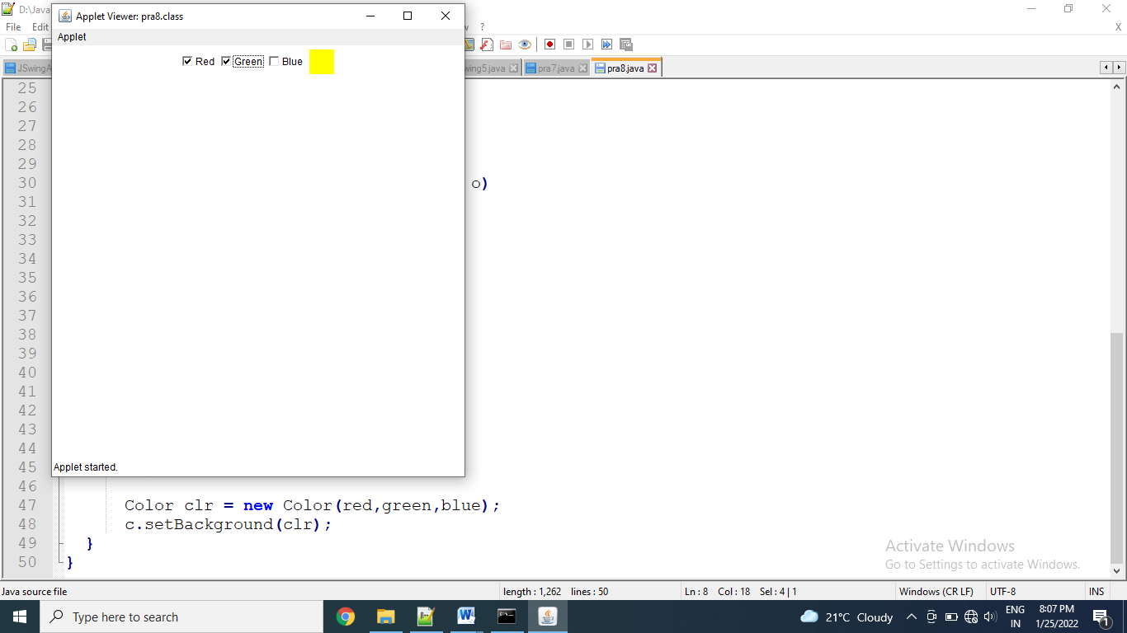

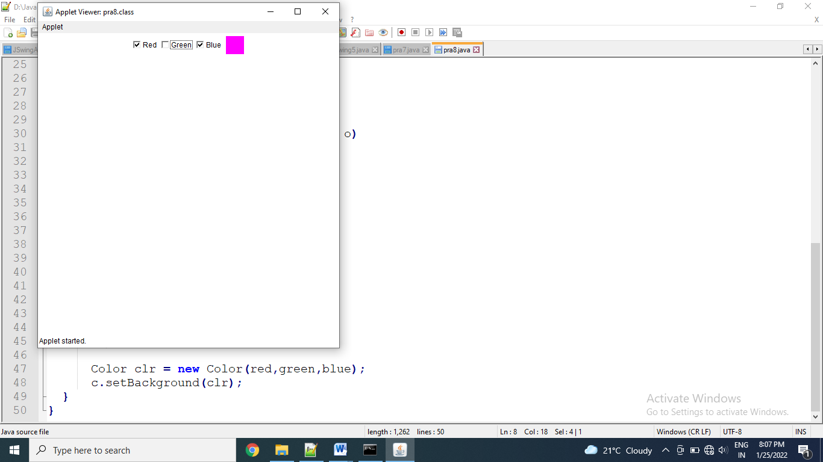

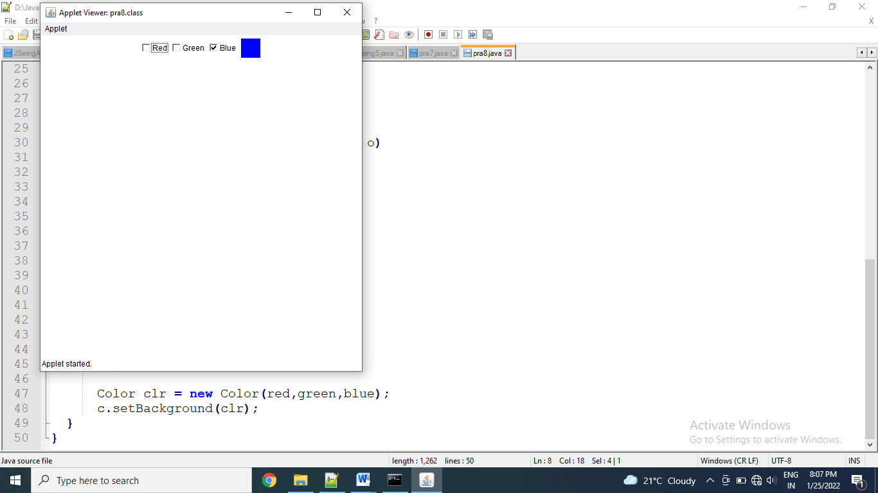

Exercise:

Write an applet that contains three buttons OK,CANCEL and HELP and a text field. if OK is pressed shown on the status bar-“OK is pressed” and the text field should turn red. When CANCEL is pressed -shown on the status bar-“ CANCEL is pressed” and text field should turn green. When HELP is pressed- shown on the status bar-“HELP is pressed” and the text field should turn yellow

Code:

import java.awt.*;

import java.applet.*;

//<applet code="pra8e1.class" height=500 width=500></applet>

public class pra8e1 extends Applet

{

Button b1 = new Button("OK");

Button b2 = new Button("CANCLE");

Button b3 = new Button("HELP");

TextField tf1 = new TextField(15);

public void init()

{

add(tf1);

add(b1);

add(b2);

add(b3);

}

public boolean action(Event e,Object o)

{

if(e.target.equals(b1))

{

getAppletContext().showStatus("OK is pressed");

tf1.setBackground(Color.RED);

}

if(e.target.equals(b2))

{

getAppletContext().showStatus("CANCLE is pressed");

tf1.setBackground(Color.GREEN);

}

if(e.target.equals(b3))

{

getAppletContext().showStatus("HELP is pressed");

tf1.setBackground(Color.YELLOW);

}

return true;

}

}

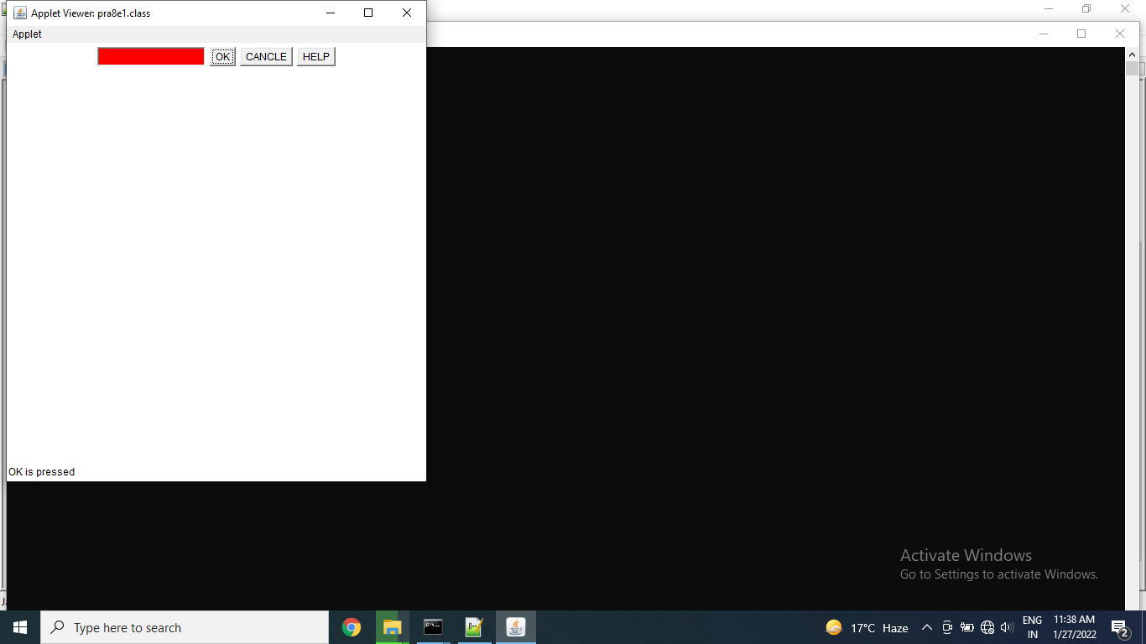

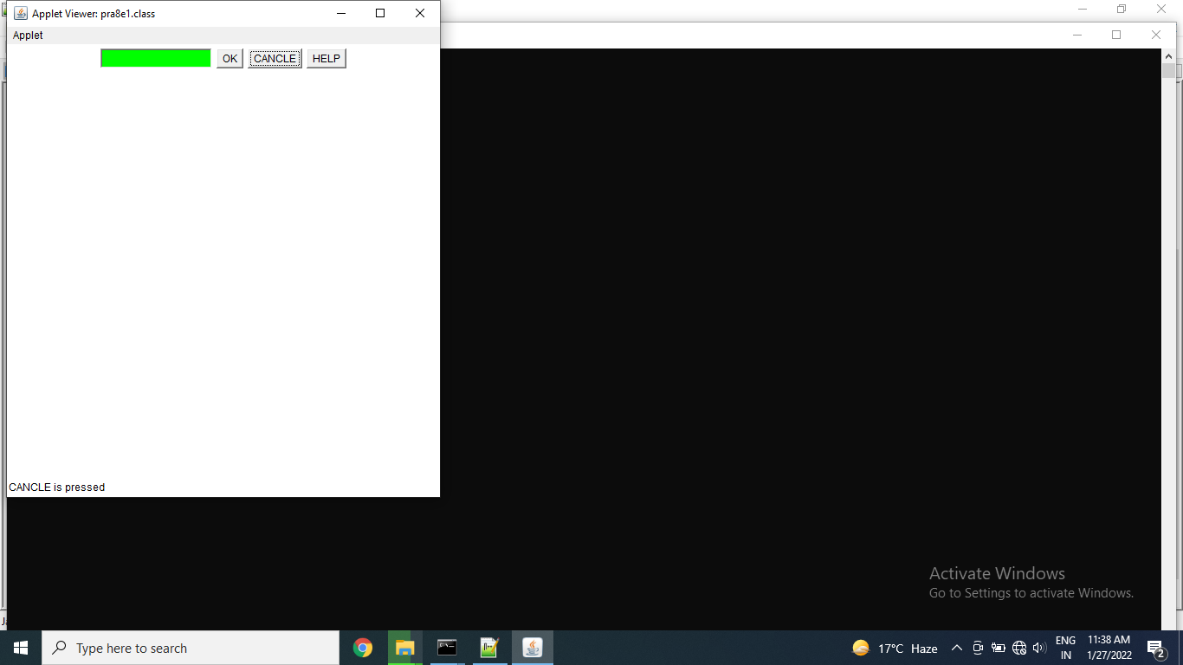

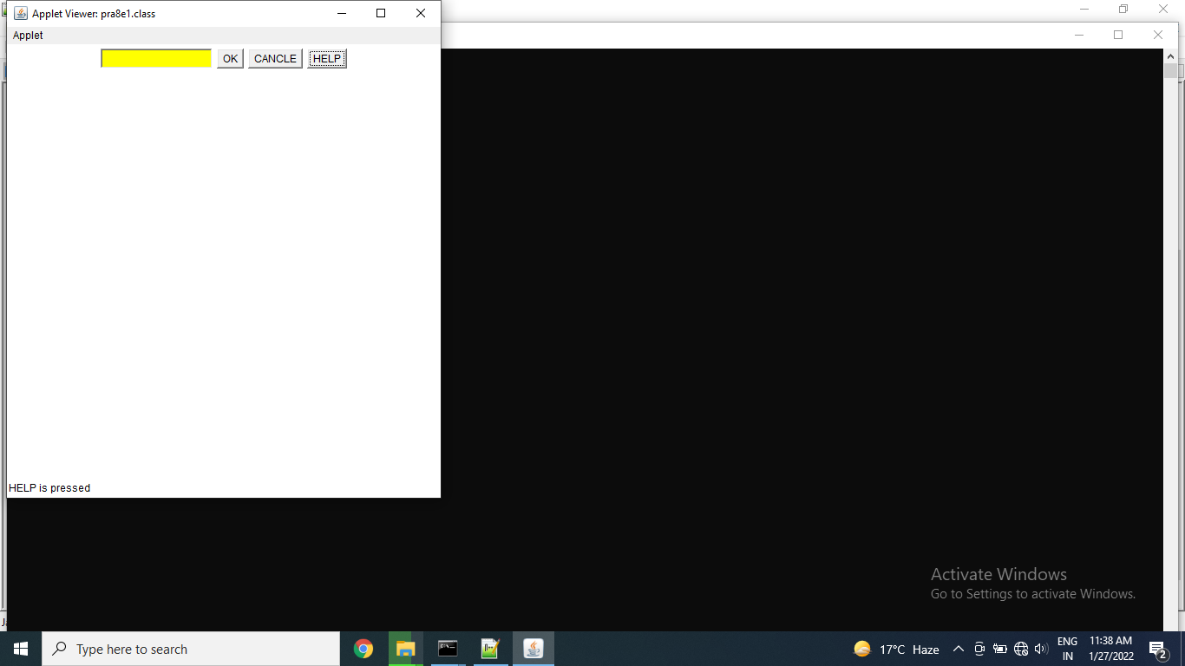

Thanks mam!!